Confidence Interval and Margin of Error:

Point estimate:

Sample mean ($\overline{x}$) is used to estimate Population mean($μ$)

There can be a difference between a single point estimate and the actual parameter value

So we should define a range of confidence interval

Whereby we can say our point estimate lies within that range

Thus, we would be able to represent the estimate of the unknown population parameter

Confidence Interval:

Formula:

Point Estimate $±$ Margin of Error

+ \* , In the case of Z Test

For T test, we will refer to the T Table instead of the Z table.

Example: On the verbal section of CAT exam, the standard deviation is known to be 100. A sample of 30 test takers has a mean of 520. Construct 95% Confidence Interval about the mean.

We basically need to find the range.

$α$ = 0.05, so $α/2$ = 0.025

Whenever we say $\frac{α}{2}$, we refer to a two tailed test

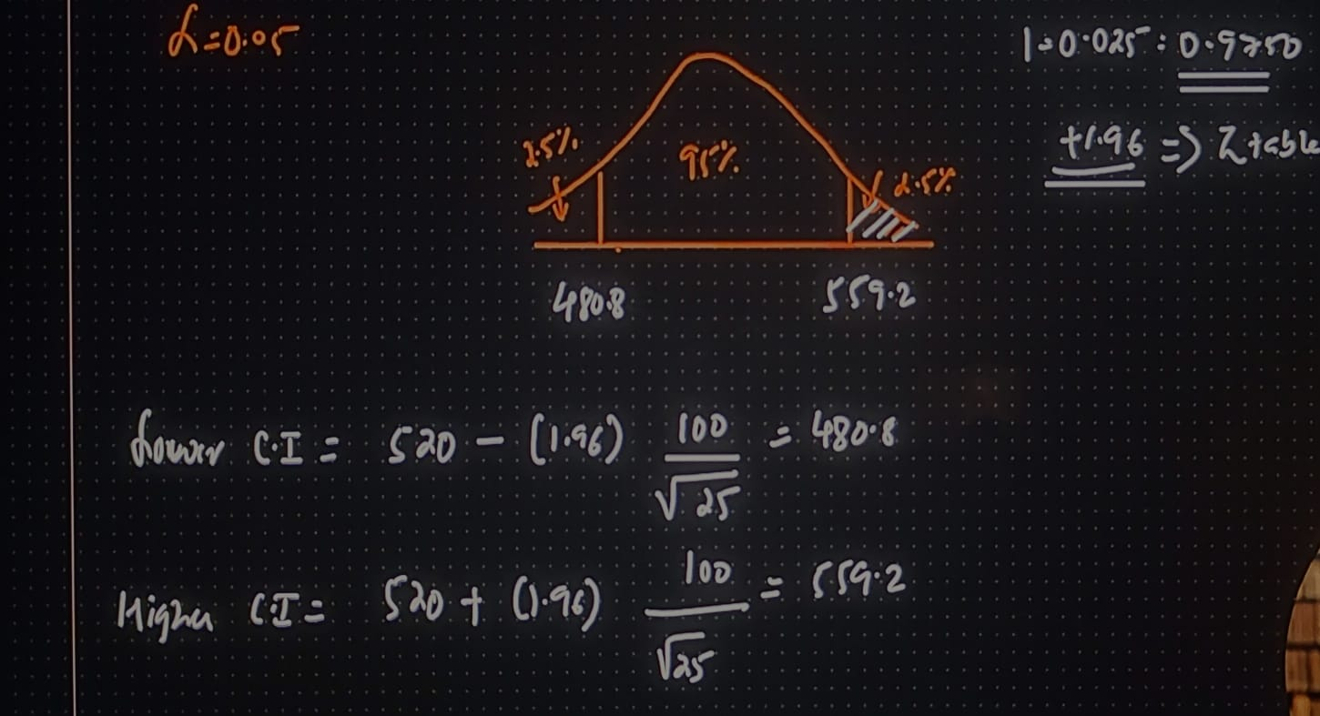

Thus, we can say with 95% confidence that the mean CAT score will lie between 480.8 and 559.2.